1. Discuss the Need of AWS?

Trade fixed expense for variable expense – Instead of having to invest heavily in data centers and servers before you know how you’re going to use them, you can pay only when you consume computing resources, and pay only for how much you consume.

Benefit from massive economies of scale – By using cloud computing, you can achieve a lower variable cost than you can get on your own. Because usage from hundreds of thousands of customers is aggregated in the cloud, providers such as AWS can achieve higher economies of scale, which translates into lower pay as-you-go prices.

Stop guessing capacity – Eliminate guessing on your infrastructure capacity needs. When you make a capacity decision prior to deploying an application, you often end up either sitting on expensive idle resources or dealing with limited capacity. With cloud computing, these problems go away. You can access as much or as little capacity as you need, and scale up and down as required with only a few minutes’ notice.

Increase speed and agility – In a cloud computing environment, new IT resources are only a click away, which means that you reduce the time to make those resources available to your developers from weeks to just minutes. This results in a dramatic increase in agility for the organization, since the cost and time it takes to experiment and develop is significantly lower.

Stop spending money running and maintaining data centers – Focus on projects that differentiate your business, not the infrastructure. Cloud computing lets you focus on your own customers, rather than on the heavy lifting of racking, stacking, and powering servers.

Go global in minutes – Easily deploy your application in multiple regions around the world with just a few clicks. This means you can provide lower latency and a better experience for your customers at minimal cost.

1. Elaborate about the challenges that are faced using AWS?

* AWS service limits. AWS service limits are set by the platform. ...
* Technology limitations. An exceptional characteristic of this limiting factor is that it can be applied to all Cloud services, not just on AWS. ...
* Lack of relevant knowledge by your team. ...
* Technical support fee. ...
* General Cloud Computing issues.

1. List out 7 services that are provided by AWS

AWS Lambda

AWS Configs

AWS Cloudwatch

AWS Billing

AWS CloudTrail

AWS CloudFront

AWS Aurora

1. Discuss a few points regarding AWS Cloud History

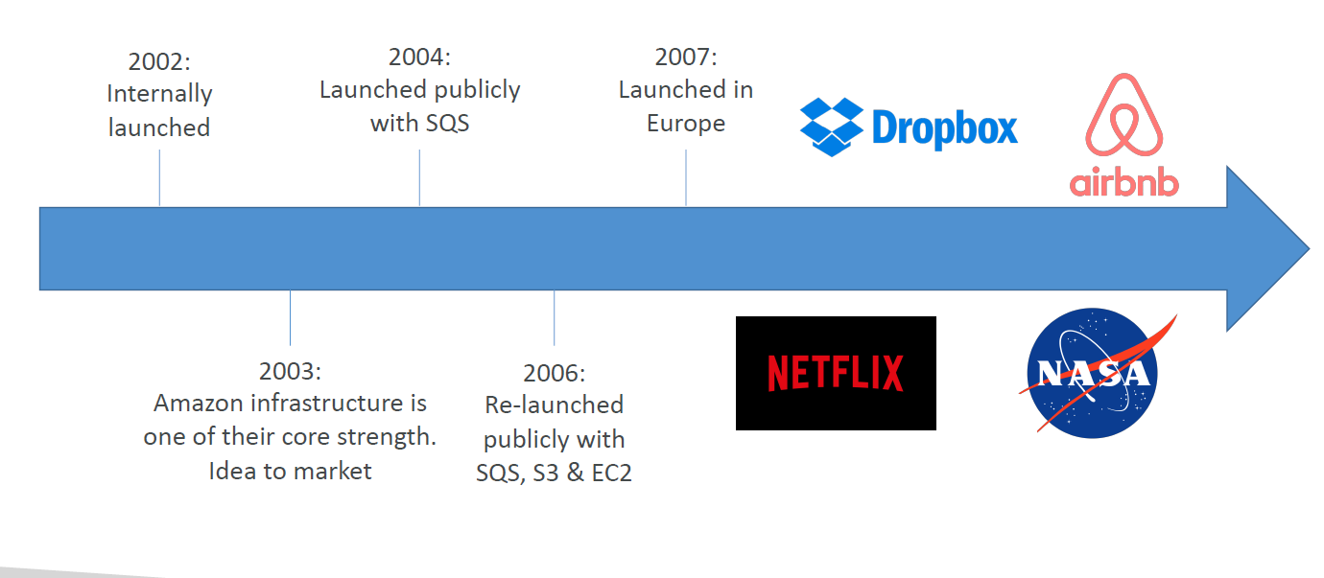

1. Explain in detail about AWS Use cases

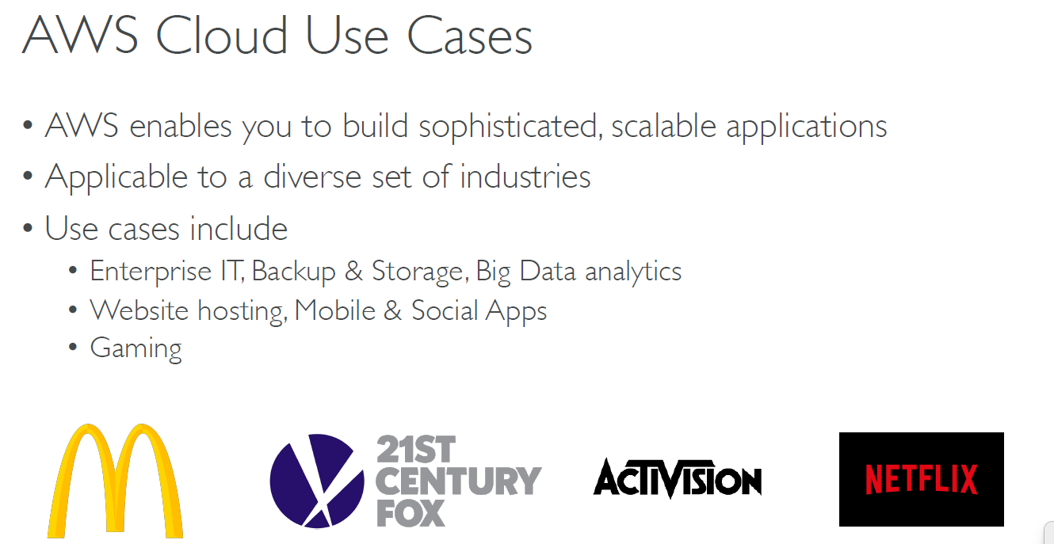

1. Elaborate in detail about AWS Global Infrastructure

* AWS Regions
* AWS Availability Zones
* AWS Data Centers
* AWS Edge Locations
* Points of Presence

1. How to choose an AWS Region? Justify

* Compliance with data governance and legal
* requirements: data never leaves a region without your explicit permission
* Proximity to customers: reduced latency
* Available services within a Region: new services and new features aren’t available in every Region
* Pricing: pricing varies region to region and is transparent in the service pricing page

1. Explain AWS Availability Zones with an example

* Each region has many availability zones (usually 3, min is 2, max is 6). Example:

• ap-southeast-2a

• ap-southeast-2b

• ap-southeast-2c

* Each availability zone (AZ) is one or more discrete data centers with redundant power, networking, and connectivity
* They’re separate from each other, so that they’re isolated from disasters
* They’re connected with high bandwidth, ultra-low latency networking

1. Discuss in detail about IAM- Users and Groups

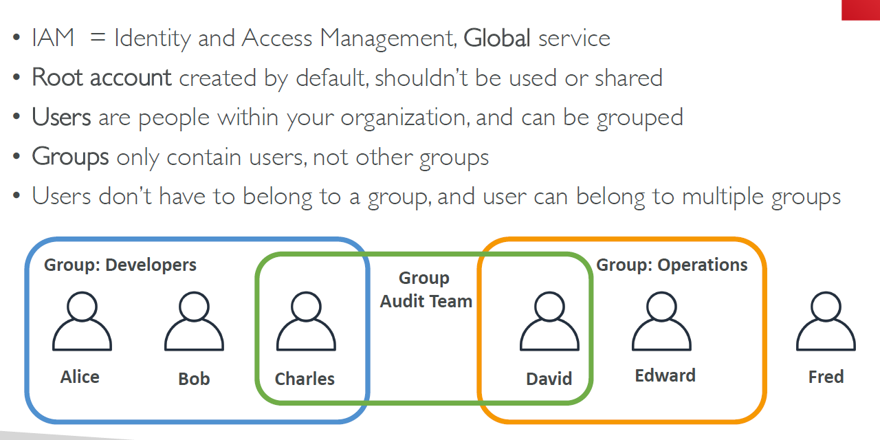

1. Explain about IAM Policies and Permission with a sample JSON document

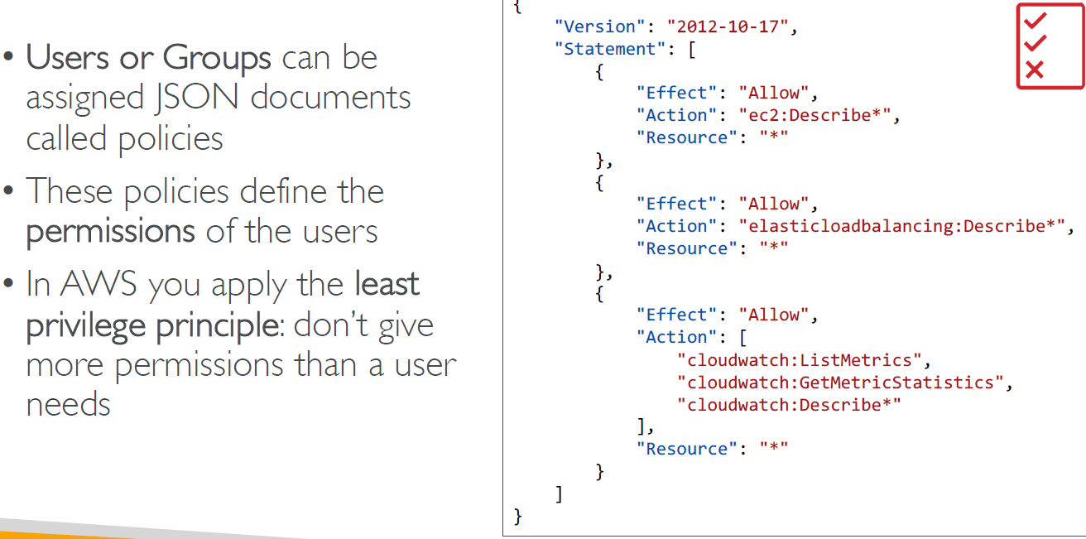

1. Explain the following
2. Policy Inheritance

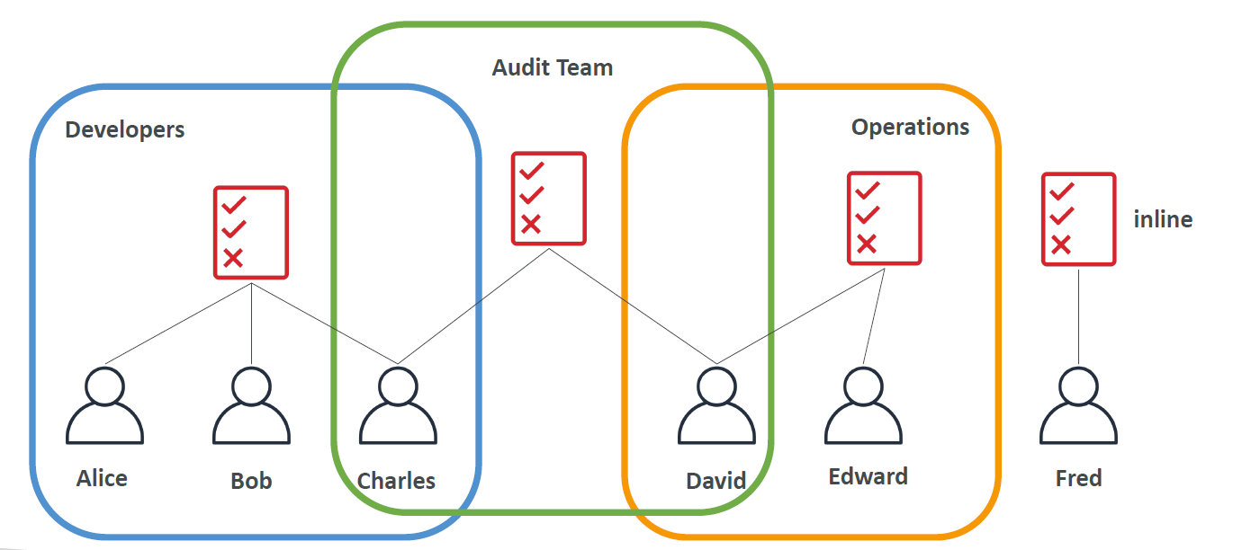

1. Policy Structure

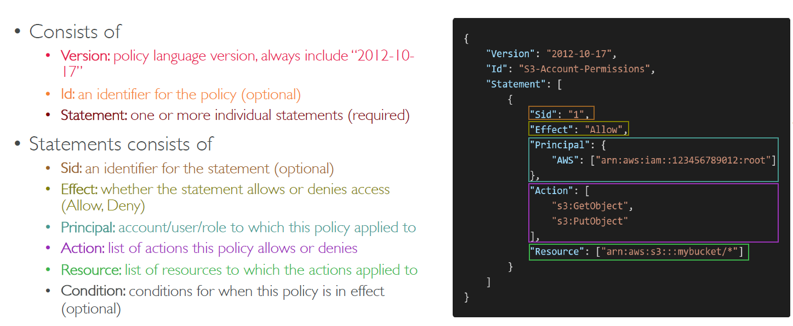

1. Explain in detail about Multi Factor Authentication

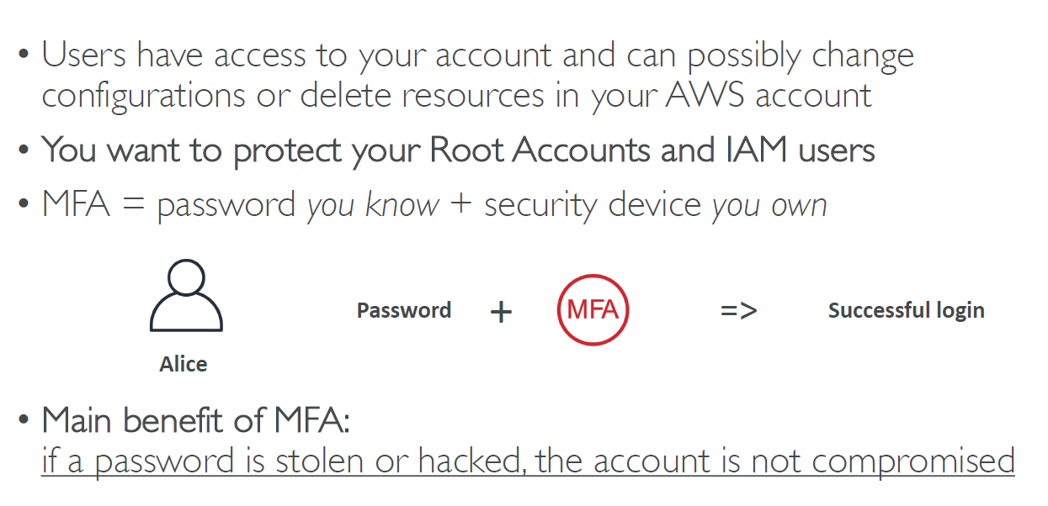

1. How can user access AWS?

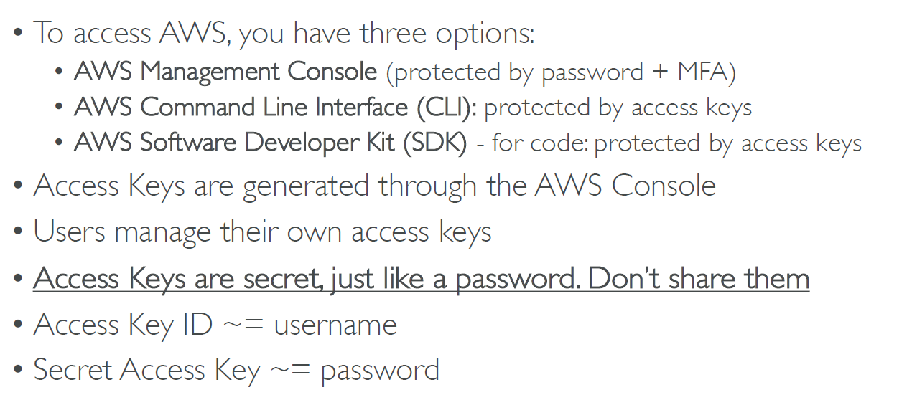

1. Discuss in detail about Amazon EC2.

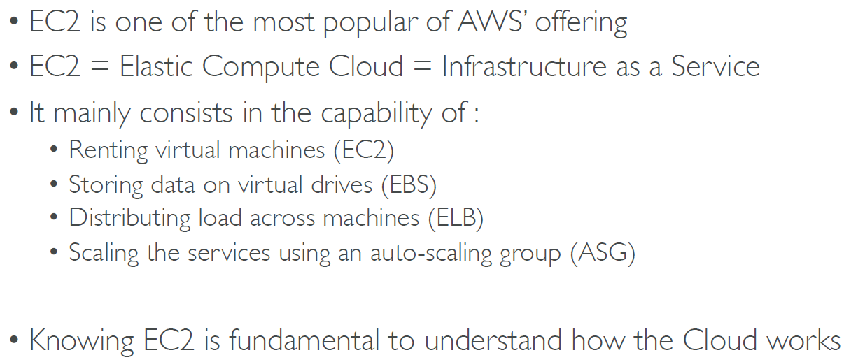

1. Explain in detail about EC2 Instant Types

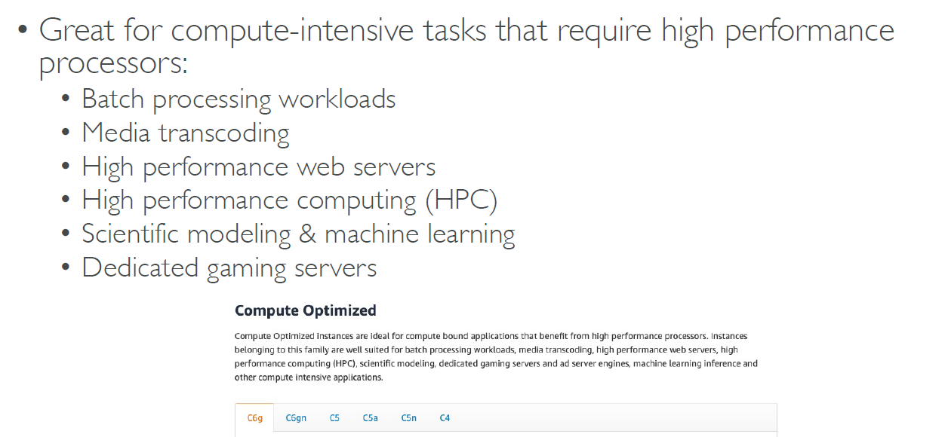

1. What are Security Groups? How far it is useful in terms of providing Services?

